# Hadoop on Azure Virtual Machines

## Hortonworks HDP Edition

The framework will automate many of the steps for creating a Hadoop cluster on Windows Azure Virtual Machines. This framework is designed to deploy Hortonworks HDP on Linux using Ambari.

The framework will automate the generation of the Azure based infrastructure, and walk through the manual steps to configure the environment. The framework is a blend of PowerShell based automation coupled with manual configuration.

The following instructions were tested on Oracle Linux 6 and CentOS 6.3/6.4. Ambari installation will fail with CentOS 6.5 at the time of this document.

# Requirements

* Windows Azure PowerShell: <http://www.windowsazure.com/en-us/documentation/articles/install-configure-powershell/>
* PuTTY or another SSH tool.
* Windows Azure Subscription with Storage Account. Steps below assist with creating the storage account and containers.
  + Create a public container in the account and move the st.pl perl script to the container

# Overview

1. Execute 1_Management_Master_Nodes.ps1
   1. Create the Affinity Group
   2. Create the Virtual Network
   3. Create the Management Node
   4. Create the Master Node
2. Manually configure the Management and Master nodes
   1. Attach disk (Management Node only)
   2. Set root passwords
   3. Set up passwordless SSH between the Management Node and the Master Node
   4. Set various server configurations to meet HDP requirements
   5. Update host files
3. Prepare the Master Node for provisioning
   1. Update waagent.conf (Master Node only)
   2. Run waagent –deprovision (Master Node only)
4. Create the Windows Azure Image
   1. Stop the Master Node
   2. Capture an image
5. Execute 2_Cluster_Nodes
   1. Creates multiple Windows Azure Virtual Machines using the Master Node image
6. Install Ambari on Management Node
7. Install HDP using Ambari

# Installing HDP on Windows Azure Virtual Machines

## Preparation

#### Windows Azure PowerShell

Download and install Windows Azure PowerShell: <http://www.windowsazure.com/en-us/downloads/>.

Follow online instructions for setting up the subscription with Windows Azure PowerShell: <http://www.windowsazure.com/en-us/documentation/articles/install-configure-powershell/>.

The PowerShell ISE (Integrated Scripting Environment) is often easier to use when developing and testing script execution. If you are in the traditional Windows Azure PowerShell interface, type ISE to open the PowerShell ISE.

#### Azure Storage Account

Set up a Windows Azure Storage Account. The script 0_Create_Storage_Container will create the storage account and the containers. Sample PowerShell command as follows:

**.\0_Create_Storage_Account.ps1 -affinityGroupName "AGHDP"   
-clusterStorageAccount "hdpstorage" -scriptStorageContainer "scripts"**

Copy the perl script to the container. Use AZCopy or a cloud storage management tool (ie CloudXplorer, Cloud Storage Studio 2). AZCopy is a free command line tool to move files between storage locations. AZCopy sample command as follows:

**Azcopy <source file location> https://<destaccount>.blob.core.windows.net/<destcontainer>/ /destkey:<key>**

The perl script location will be used in the instructions below when moving the perl script to the Linux machines.

#### Configure Windows Azure PowerShell Environment

Set PowerShell defaults for the new storage account. In the PowerShell ISE execute the following command.

**Set-AzureSubscription –SubscriptionName $subscriptionName   
–CurrentStorageAccount $clusterStorageAccount**

#### PuTTY

Download and install PuTTY or another SSH tool: <http://www.putty.org>

#### Hosts File

Create a host file for the nodes in the cluster. A sample host file will appear like the following:

172.16.0.4 HDPNode0

172.16.0.5 HDPNode1

172.16.0.6 HDPNode2

172.16.0.7 HDPNode3

172.16.0.8 HDPNode4

172.16.0.9 HDPNode5

172.16.0.10 HDPNode6

172.16.0.11 HDPNode7

172.16.0.12 HDPNode8

172.16.0.13 HDPNode9

#### Virtual Network Configuration Files

The way that the network is created depends on whether you have existing virtual networks defined. If your subscription has existing networks defined, you can merge the new network configuration into the existing configuration. If your subscription does not have existing networks defined, you can create the entire network from scratch. The 1_Management_Master_Nodes.ps1 script in the following step automatically detects which scenario you have and acts accordingly.

The scripts assume that the virtual network subnet does not already exist. If you are using an existing virtual network and subnet, comment out the “create virtual network” sections from the 1_Management_Master_Nodes.ps1 script.

You will create two files as defined below. The script will use these files to add the new Virtual Network configuration settings.

1. Save the following XML block into a file named “C:\Temp\NetworkDef.xml”. Replace “*insert network address*” with the appropriate network address.

<VirtualNetworkSite name="placeholder-network" AffinityGroup="placeholder-affinitygroup">

<AddressSpace>

<AddressPrefix>*insert network address*</AddressPrefix>

</AddressSpace>

<Subnets>

<Subnet name="App">

<AddressPrefix>*insert network address*</AddressPrefix>

</Subnet>

</Subnets>

</VirtualNetworkSite>

1. Save the following XML block into a file named “C:\Temp\NetworkDef-Full.xml”. Replace “*insert network address*” with the appropriate network address.

<NetworkConfiguration xmlns:xsd="http://www.w3.org/2001/XMLSchema" xmlns:xsi="http://www.w3.org/2001/XMLSchema-instance" xmlns="http://schemas.microsoft.com/ServiceHosting/2011/07/NetworkConfiguration">

<VirtualNetworkConfiguration>

<Dns />

<VirtualNetworkSites>

<VirtualNetworkSite name="placeholder-network" AffinityGroup="placeholder-affinitygroup">

<AddressSpace>

<AddressPrefix>*insert network address*</AddressPrefix>

</AddressSpace>

<Subnets>

<Subnet name="App">

<AddressPrefix>*insert network address*</AddressPrefix>

</Subnet>

</Subnets>

</VirtualNetworkSite>

</VirtualNetworkSites>

</VirtualNetworkConfiguration>

</NetworkConfiguration>

## Create the Infrastructure

Open the 1_Management_Master_Nodes.ps1 script in Windows Azure PowerShell Integrated Shell Environment (ISE).

Execute the script with the parameters representing the appropriate environment settings. All parameters are required.

|  |  |
| --- | --- |
| Parameter name | Purpose |
| $imageName | The name of the Windows Azure image which will be used for provisioning the virtual machines. |
| $adminPassword | The password that will be generated in the virtual machines for the administrator of the virtual machines. |
| $adminUserName | The user name of the administrator account that will be created on the virtual machines. |
| $instanceSize | The size of the Windows Azure Virtual Machines (ie Small, Medium, Large, ExtraLarge, etc). Virtual machine sizes are detailed online: <http://msdn.microsoft.com/en-us/library/windowsazure/dn197896.aspx>. |
| $diskSizeInGB | The size of the disk to attach to the virtual machines. |
| $numofDisks | The number of disks to attach to the virtual machines. |
| $vmNamePrefix | Naming convention for the virtual machines. All virtual machines will be named based on this prefix. |
| $cloudServicePrefix | Naming convention for the cloud services. In general, this will be the same as the $vmNamePrefix for ease of management. |
| $affinityGroupLocation | The Windows Azure data center where the virtual machines will be deployed. Choose a data center that is the same location as the storage account with the data to analyze.  Execute Get-AzureLocation from PowerShell or “azure vm location list” from the Azure Command Line to the the complete list of locations. |
| $affinityGroupName | The name of the affinity group (must be unique in your subscription). |
| $affinityGroupDescription | The description for the affinity group. |
| $affinityGroupLabel | The label for the affinity group. |
| $virtualNetworkName | The name for the virtual network (must be unique in your subscription). |
| $virtualNetworkName | The name for the virtual network (must be unique in your subscription). |
| $virtualSubnetName | The name of the virtual subnet. |

#### Sample Execution Script

.\1_Management_Master_Nodes.ps1 -imageName "Oracle Linux 6.4.0.0.0" -adminUserName "clusteradmin" -adminPassword "Password.1" -instanceSize "ExtraLarge" -diskSizeInGB 100 -numOfDisks 2 -vmNamePrefix "HDPNode" -cloudServicePrefix "HDPNode" -affinityGroupLocation "East US" -affinityGroupName "AGHDP" -affinityGroupDescription "Affinity Group used for HDP on Azure VM" -affinityGroupLabel "Hadoop on Azure VM AG HDP" -virtualNetworkName "Hadoop-NetworkHDP" -virtualSubnetname "App"

## Manually configure the Management and Master nodes

The Management Node is named $vmNamePrefix followed by 0, and the Master Node is named $vmNamePrefix followed by M. You will use PuTTY to configure these nodes.

You may need the Management Node private IP and the Master Node private IP to proceed with this section. The virtual machine IP addresses can be found by viewing the properties of the virtual machine in the [Windows Azure Management Portal](https://manage.windowsazure.com/).

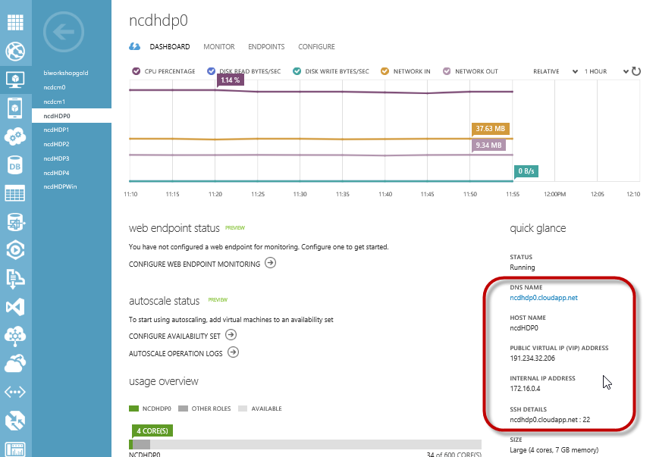

Open PuTTY and input port 22 with the Management Node public IP address or the DNS name. Click Open.

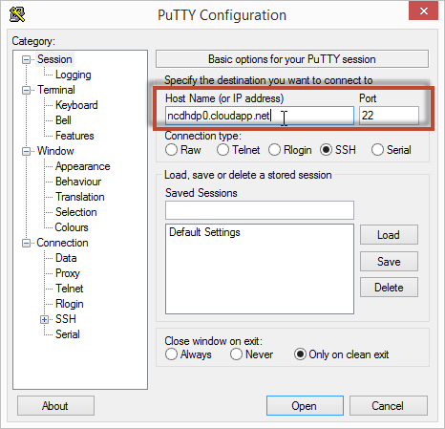

You will be prompted for a login and password. Enter the value used in the variable $adminUserName with the password $adminPassword.

### Set root passwords

The first steps will be to set the root passwords on both the Management and Master Nodes. You are currently connected to the Management Node.

Elevate to root. Enter the password for the $adminUserName when prompted. Update the root password. Enter the new password when prompted.

**sudo –s**

**passwd**

Enter the following to move to the Master Node. Enter the password for the adminUserName when prompted.

**ssh <adminUserName>@<Master Node Hostname>.cloudapp.net**

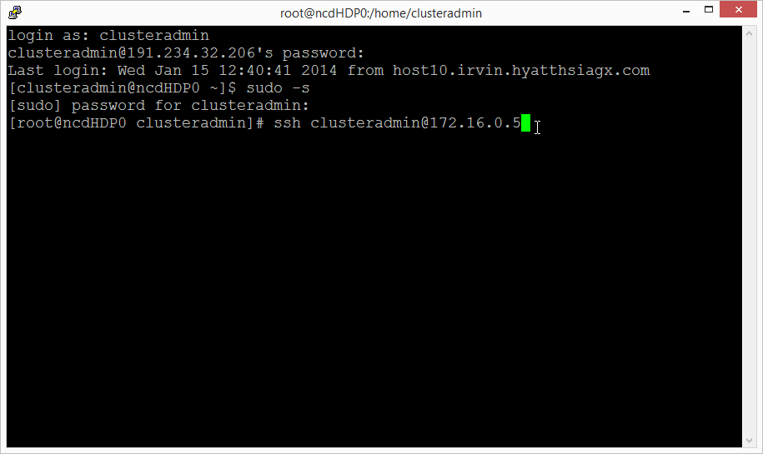

Elevate to root. Enter the password for the $adminUserName when prompted.

Update the root password. Enter the new password when prompted.

**sudo –s**

**passwd**

With both root passwords set we can now configure the nodes for the cluster.

### Management Node Configuration

Return to the Management Node. Enter the ***root*** password when prompted.

**ssh <Management Node Hostname>.cloudapp.net**

#### Update Kernel-Header

If you are using the gallery image “Oracle Linux 6.4.0.0.0”, the following steps must be executed for a successful installation of HDP.

Update the yum conf file. Comment out the line “exclude=kernel-uek-headers”

**vi /etc/yum.conf**

**# exclude=kernel-uek-headers**

Update kernel headers.

**yum install kernel-headers**

#### Mount Disks

The disks will be mounted based on a startup script. The perl script st.pl should be saved to an Azure public container in your storage account.

Install perl and open the perl shell, typing “yes” when prompted.

**yum -y install perl-CPAN**

**perl -MCPAN -e shell**

Run the following commands in the perl shell.

**install List::MoreUtils**

**install IPC::System::Simple**

**install Time::Format**

**quit**

If you are using the gallery image “Oracle Linux 6.4.0.0.0” install wget.

**yum install wget**

Download the perl script and move the perl script to script folder. The url of the perl script is based on the storage account and container created in the Preparation section.

**wget <url of perl script in the Azure blob container>**

*(ex: wget* [*http://hoa.blob.core.windows.net/hdpscripts/st.pl*](http://hoa.blob.core.windows.net/hdpscripts/st.pl)*)*

**mkdir scripts**

**mv st.pl scripts/st.pl**

**chmod 755 scripts/st.pl**

Open crontab to add the startup script command.

**vi /etc/crontab**

Add the following line to the end of the file. Type i to enter insert mode:

**@reboot root perl /root/scripts/st.pl**

Press esc to exit insert mode. Type :wq and press enter to save and close the file.

#### Set up passwordless SSH between the Management Node and the Master Node

In the Management Node generate the key.

**ssh-keygen**

Accept the default file location when prompted (press enter). Press enter to create the key without a passphrase. The public key is stored in .ssh/id_rsa.pub, and the private key is id_rsa. You will use the private key later during the HDP installation. At this time you will copy the public key to the Master Node to enable passwordless ssh.

Copy the key to the Master node and Management Node (self-referencing), enter the root password when prompted.

**ssh-copy-id -i /root/.ssh/id_rsa.pub root@<Master Node Hostname>.cloudapp.net**

**ssh-copy-id -i /root/.ssh/id_rsa.pub root@<Management Node Hostname>.cloudapp.net**

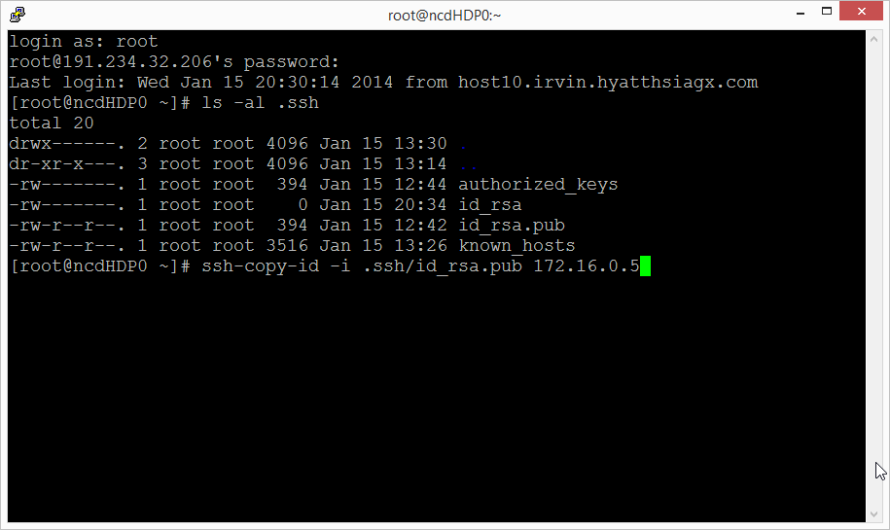

To test the keys were set up correctly, type the following and validate that you are not prompted for a password.

**ssh <Management Node Hostname>.cloudapp.net**

**ssh <Master Node Hostname>.cloudapp.net**

#### Update Host Files

Open the hosts files for editing

**vi /etc/hosts**

Paste the host data at the end of the file. Press esc to exit insert mode. Type :wq and press enter to save and close the file.

#### Update Server Configuration Settings

Type the following commands to configure the server settings for HDP prerequisites.

**#disable iptables**

**chkconfig iptables off**

**/etc/init.d/iptables stop**

**setenforce 0**

**#start ntp service**

**chkconfig ntpd on**

**ntpdate pool.ntp.org**

### Master Node Configuration

Return to the Master Node. You should not be prompted for a password.

**ssh <Master Node Hostname>.cloudapp.net**

#### Update Kernel-Header

If you are using the gallery image “Oracle Linux 6.4.0.0.0”, the following steps must be executed for a successful installation of HDP.

Update the yum conf file. Comment out the line “exclude=kernel-uek-headers”

**vi /etc/yum.conf**

**# exclude=kernel-uek-headers**

Update kernel headers.

**yum install kernel-headers**

#### Mount Disks

The disks will be mounted based on a startup script named st.pl. The perl script st.pl should be saved to an Azure public container in your storage account.

Install perl and open the perl shell, typing “yes” when prompted.

**yum -y install perl-CPAN**

**perl -MCPAN -e shell**

From the perl shell, install the necessary perl modules.

**install List::MoreUtils**

**install IPC::System::Simple**

**install Time::Format**

**quit**

If you are using the gallery image “Oracle Linux 6.4.0.0.0” install wget.

**yum install wget**

Download the perl script and move the perl script to script folder

**wget <url of perl script in the Azure blob container>**

*(ex: wget* [*http://hoa.blob.core.windows.net/hdpscripts/st.pl*](http://hoa.blob.core.windows.net/hdpscripts/st.pl)*)*

**mkdir scripts**

**mv st.pl scripts/st.pl**

**chmod 755 scripts/st.pl**

Update crontab to add the startup script.

**vi /etc/crontab**

Add the following line to the end of the file.

**@reboot root perl /root/scripts/st.pl**

#### Update Host Files

Open the hosts files for editing.

**vi /etc/hosts**

Paste the host data at the end of the file. Press esc to exit insert mode. Type :wq and press enter to save and close the file.

#### Update Server Configuration Settings

Configure the server settings for HDP prerequisites.

**#disable iptables**

**chkconfig iptables off**

**/etc/init.d/iptables stop**

**setenforce 0**

**#start ntp service**

**chkconfig ntpd on**

**ntpdate pool.ntp.org**

#### Windows Azure Linux Agent

Set up the virtual machine for provisioning as an image. Open the waagent.conf file.

**vi /etc/waagent.conf**

Change the following settings:

**Provisioning.DeleteRootPassword=n**

**Provisioning.RegenerateSshHostKeyPair=n**

Press esc to exit insert mode. Type :wq and press enter to save and close the file.

Run the Windows Azure Linux Agent.

**waagent –deprovision**

Return to the Management Node.

**ssh <Management Node Hostname>.cloudapp.net**

## Capture the Master Image

Open the Windows Azure Management Portal and navigate to the dashboard of the Master Node virtual machine. Shut down the machine. After the machine is stopped, click Capture to create an image.

## Create the Cluster

Open the 2_Cluster_Nodes.ps1 script in Windows Azure PowerShell Integrated Shell Environment (ISE).

Execute the script with the parameters representing the appropriate environment settings. Most of the parameters will be the same values as the 1_Management_Master_Nodes.ps1 script except $imageName, which will be the name of the image you captured in the previous step. You will also add a $numNodes parameter for the count of virtual machines to generate. All parameters are required.

|  |  |
| --- | --- |
| Parameter name | Purpose |
| $imageName | The name of the Master Node image which will be used for provisioning the virtual machines. |
| $adminPassword | The password that will be generated in the virtual machines for the administrator. |
| $adminUserName | The user name of the administrator account. |
| $instanceSize | The size of the Windows Azure Virtual Machines (ie Small, Medium, Large, ExtraLarge, etc). |
| $diskSizeInGB | The size of the disk to attach to the virtual machines. |
| $numofDisks | The number of disks to attach to the virtual machines |
| $vmNamePrefix | Naming convention for the virtual machines. All virtual machines will be named based on this prefix. |
| $cloudServicePrefix | Naming convention for the cloud services. In general, this will be the same as the $vmNamePrefix for ease of management. |
| $numNodes | The total number of virtual machines to create for the cluster. |
| $affinityGroupLocation | The Windows Azure data center where the virtual machines will be deployed. |
| $virtualNetworkName | The name for the virtual network (must be unique in your subscription). |
| $virtualSubnetName | The name of the virtual subnet. |

#### Sample Execution Script

.\2_Cluster_Nodes.ps1 -imageName "ncdhdpm" -adminUserName "clusteradmin" -adminPassword "Password.1" -instanceSize "ExtraLarge" -diskSizeInGB 100 -numofDisks 2 -vmNamePrefix "ncdHDP" -cloudServicePrefix "ncdHDP" -numNodes 8 -affinityGroupName "ncdAGHDP" -virtualNetworkName "Hadoop-NetworkHDP" -virtualSubnetname "App" -isManagementNode "False"

At the completion of the script, you will have a set of virtual machines to install Hadoop.

To test the virtual machines were generated correctly, open a PuTTY connection from the Management node and connect to a few of the machines to verify the host name and to verify passwordless ssh is working:

**ssh <Machine Hostname>.cloudapp.net**

**hostname**

## Install Ambari

Open an SSH session in PuTTY to the Management Node.

Download and install Ambari:

**wget http://public-repo-1.hortonworks.com/ambari/centos6/1.x/updates/1.4.2.104/ambari.repo**

**cp ambari.repo /etc/yum.repos.d**

**yum install ambari-server**

After the installation has completed, run the setup:

**ambari-server setup**

## Restart VMs

Restart all VMs to ensure the disks are mounted. Using PowerShell:

$imageNamePrefix = "HDPNode"

Get-AzureVM | where {$_.Name -like "*$imageNamePrefix*"} | Restart-AzureVM

After the management node is restarted, verify Ambari is started. Connect to the Management Node in PuTTY and execute the following command:

**ambari-server start**

## Install HDP

Open the browser and navigate to http://<Management Node Hostname>:8080

When prompted, log in as admin with password admin.

In general, follow the prompts to install. The only tricky part I would point out is in the install screen to input hosts and the key. You will paste the private key from the Management Node:

**cat .ssh/id_rsa**

Highlight the full key and press enter to copy to the clipboard. You will then paste this in the web interface.